Contents

**Component of Time series Data** 3

**A) Time Series Data:** 3

**B) Time Series Analysis:** 3

**C) Time Series Forecasting:** 3

**GOAL-PLAN-FORECAST** 3

**Basic steps involved in any forecasting problem** 4

**Three important characteristics of time series data** 5

**Components associated with time series** 5

**1)** **Level:** 5

**2)** **Trend:** 5

**3)** **Seasonality:** 6

**4)** **Cyclicity:** 6

**5)** **Noise:** 6

**Handling missing values in Time series** 7

**1.Mean Imputation** 7

**2.Last observation carried forward**: 7

**3.Linear interpolation** 7

**4.Seasonal + Linear interpolation** 8

**Method of detecting outliers:** 8

**2.Box Plot** 9

**3.Histogram:** 9

**Handling Outliers in Time series Data** 9

**Time series Decomposition** 10

**Additive Seasonal Decomposition** 10

**Multiplicative Seasonal Decomposition** 10

**Time Series VS Regression** 10

**Forecasting methods** 12

**1.Naive method** 12

**2.Simple average method: -** 12

**Popular error measures** 13

**Mean Forecast Error (MFE):** 13

**Mean Absolute Error (MAE):** 14

**Mean Absolute Percentage Error (MAPE):** 14

**Mean Squared Error (MSE):** 14

**Root Mean Squared Error (RMSE):** 15

**Cross-validation** 15

**One-Step Validation** 15

**Multi-Step Validation** 16

**Types of Forecasting**

Types of Forecasting There are two types of forecasting. They are:

1. Qualitative forecasting 2. Quantitative forecasting

The following are the differences between the quantitative and qualitative forecasting

One of the quantitative forecasting methods is time series forecasting.

# **Fundamental terms of Time series Data**

**A) Time Series Data:** Any data that has a time component involved in it is termed as a time-series data. For example, the number of orders made on a food ordering app per day is an example of time-series data.

**B) Time Series Analysis:** Performing analysis on a time-series data to find useful insights and patterns in termed as time series analysis. Let's take a food ordering app example again. The app might have the data for every day logged in per hour. They might notice that in this data, the number of orders is significantly higher in, say, the 1-2 PM time slot but is significantly lower in the 3-4 PM time slot. This information might be useful for them as they would then be able to estimate the number of delivery boys required at a particular time of the day. Hence, time series analysis is indispensable while working with any time series data.

**C) Time Series Forecasting:** Time series forecasting is basically looking at the past data to make predictions into the future. Say that the food ordering app wants to predict the number of orders per day for the next month in order to plan the resources better. For this, they will look at tons of past data and use it in order to forecast accurately.

# **GOAL-PLAN-FORECAST**

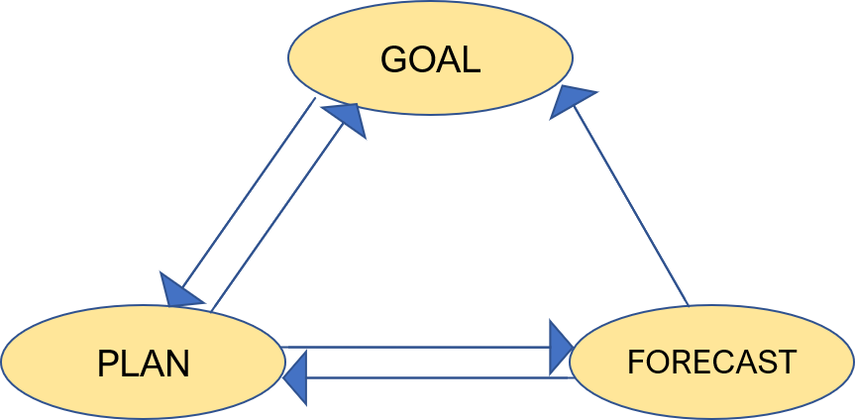

• **Goal**: A set of business objectives. For example, maximising revenue, maximising capital, etc.

• **Plan**: A set of actions that a business takes to achieve the goal. In order to come up with a good plan, they need a forecast.

• **Forecast**: Is the prediction of the future.

# **Basic steps involved in any forecasting problem**

* Define the problem
* Collect the data
* Analyze the data
* Build and evaluate the forecast model

**Some Caveats in Time series Forecasting**

There are some ***caveats*** associated with a time series forecasting.

**The Granularity Rule**: The more aggregate your forecasts, the more accurate you are in your predictions simply because aggregated data has lesser variance and hence, lesser noise.

As a thought experiment, suppose you work at ABC, an online entertainment streaming service, and you want to predict the number of views for a few newly launched TV show in Mumbai for the next one year. Now, would you be more accurate in your predictions if you predicted at the city-level or if you go at an area-level? Obviously, accurately predicting the views from each area might be difficult but when you sum up the number of views for each area and present your final predictions at a city-level, your predictions might be surprisingly accurate. This is because, for some areas, you might have predicted lower views than the actual whereas, for some, the number of predicted views might be higher. And when you sum all of these up, the noise and variance cancel each other out, leaving you with a good prediction. Hence, you should not make predictions at very granular levels.

**The Frequency Rule**: This rule tells you to keep updating your forecasts regularly to capture any new information that comes in.

Let's continue with the ABC, an online entertainment streaming service, an example where the problem is to predict the number of views for a newly launched TV show in Mumbai for the next year. Now, if you keep the frequency too low, you might not be able to capture accurately the new information coming in. For example, say, your frequency for updating the forecasts is 3 months. Now, due to the COVID-19 pandemic, the residents may be locked in their homes for around 2-3 months during which the number of views will significantly increase. Now, if the frequency of your forecast is only 3 months, you will not be able to capture the increase in views which may incur significant losses and lead to mismanagement.

**The Horizon Rule:** When you have the horizon planned for a large number of months into the future, you are more likely to be accurate in the earlier months as compared to the later ones. Let's again go back to ABC, an online entertainment streaming service, example. Suppose that the online entertainment streaming service made a prediction for the number of views for the next 6 months in December 2019. Now, it may have been quite accurate for the first two months, but due to the unforeseen COVID-19 situation, the actual number of view in the next couple of months would have been significantly higher than predicted because of everyone staying at home. The farther ahead we go into the future, the more uncertain we are about the forecasts.

Now that you have understood the steps in defining the problem, let’s apply them to the air passenger traffic problem.

* **Quantity**: Number of passengers
* **Granularity**: Flights from city A to city B; i.e., flights for a particular route
* **Frequency**: Monthly
* **Horizon**: 1 year (12 months)

# **Three important characteristics of time series data**

There are three important characteristics that every time series data must exhibit in order for us to make a good forecast.

* **Relevant**: The time-series data should be relevant for the set objective that we want to achieve.
* **Accurate**: The data should be accurate in terms of capturing the timestamps and capturing the observation correctly.
* **Long enough**: The data should be long enough to forecast. This is because it is important to identify all the patterns in the past and forecast which patterns repeat in the future.

# **Components associated with time series**

It seems like there are quite a few components associated with time series. Let's look at them one by one once again.

1. **Level:** This is the baseline of a time series. This gives the baseline to which we add the different other components.
2. **Trend:** Over a longterm, this gives an indication of whether the time series moves lower or higher. For example, in the following Sensex graph you can clearly observe that with time, the overall value is increasing i.e. this particular time series data has an increasing trend.

Every time series has a level and noise, while trend, seasonal and cyclic patterns are optional.Every time series has a level and noise, while trend, seasonal and cyclic patterns are optional.

1. **Seasonality:** It is a pattern in a time-series data that repeats itself after a given period of time. For example, in the following graph 'Monthly sales data of company X', you can clearly observe that a fixed pattern is repeating every year. The simplest example to explain this could be, say, the sales of winter wear in India. In winter, during months like November-January, you would expect these sales to be very high whereas for the other months, the sales might be low. This shows a seasonality pattern and proves to be very useful when making forecasts.

1. **Cyclicity:** It is also a repeating pattern in data that repeats itself aperiodically. We don’t get into the more details of this component as it is out of the scope of this module.Cyclicity: It is also a repeating pattern in data that repeats itself aperiodically. We don’t get into the more details of this component as it is out of the scope of this module.

1. **Noise:** Noise is the completely random fluctuation present in the data and we cannot use this component to forecast into the future. This is that component of the time series data that no one can explain and is completely random.

# **Handling missing values in Time series**

Methods of handling missing values.

**1.Mean Imputation**: Imputing the missing values with the overall mean of the data.

**2.Last observation carried forward**: We impute the missing values with its previous value in the data.

**3.Linear interpolation:** You draw a straight line joining the next and previous points of the missing values in the data.

**4.Seasonal + Linear interpolation:** This method is best applicable for the data with trend and seasonality. Here, the missing value is imputed with the average of the corresponding data point in the previous seasonal period and the next seasonal period of the missing value.

# **Method of detecting outliers:**

It is important before we even start building the time series models, we should check the dataset for outliers as well apart from missing values in the dataset. This will help us analyze the forecast plots more accurately.

1.**Extreme value analysis**: Remove the smallest and largest values in the dataset.

**2.Box Plot**: The points lying on either side of the whiskers are considered to be outliers as shown in the image. The length of these whiskers is subjective and can be defined by you according to the problem.

**3.Histogram:** Simply plotting a histogram can also reveal the outliers - basically the extreme values with low frequencies visible in the plot.

# **Handling Outliers in Time series Data**

1. Mean,Median or Mode
2. Trimming
3. Lower and upper capping.
4. Zero capping

# **Time series Decomposition**

Time series can be split into its various components that is the

1. trend, b) seasonality, and c) residuals (residual is the part left over after extracting trend and seasonality from the time series).

The data can be decomposed to extract these two components individually.

There are two ways in which the time series data can be decomposed:

**Additive Seasonal Decomposition** - the individual components can be added to get the time-series data

When the magnitude of the seasonal pattern in the data does not directly correlate with the value of the series, the additive seasonal decomposition may be a better choice to split the time series so that the residual does not have any pattern.

**Multiplicative Seasonal Decomposition** - the individual components can be multiplied to get the time-series data

When the magnitude of the seasonal pattern in the data increases with an increase in data values and decreases with a decrease in the data values, the multiplicative seasonal decomposition may be a better choice.

# **Time Series VS Regression**

Time series is a series of time-stamped values. In other words, it is a sequence of values with time values attached to it. Here, the order attached to the values is very important which is not the case with a normal regression model.

Using time series analysis, you can forecast:

* the value of the stock market index for a future month, or
* the value of the literacy rate for a future census
* the population of a nation in the coming year

 In a time series, the sequence is important. For example, let’s take the data provided below.

Using regression or advanced regression, let’s say you predict the value for timestamp 7. Now let’s say you shuffle the data around like this.

Even though we shuffled the data in the value's column, linear regression works on the linear relationship between the variables and thus the above data will also give you the same prediction for timestamp 7 if you use regression on the second table. **However, a time series analysis will give you different forecasts for the original data and for the shuffled one**.

Why does this happen? This happens because while forecasting using time series, your model predicts not only on the basis of the values given but also on the basis of the sequence in which the values are given. Hence, the sequence is very important in a time series analysis and should not be played around with.

Two most important differences between time series and regression are:

**Time series have a strong temporal (time-based) dependence** — each of these data sets essentially consists of a series of time-stamped observations i.e. each observation is tied to a specific time instance. Thus, unlike regression, the order of the data is important in a time series.

In a time series, you are not concerned with the causal relationship between the response and explanatory variables. The cause behind the changes in the response variable is very much a black box.

For example, let’s say you want to predict what the value of the stock market index will be next month. You will not look at why the stock market index increases in value or if it’s because of an increase in GDP or there are some changes in any sector or some other factor. You will only look at the sequence of values for the past months and predict for the next month, based on that sequence.

# **Forecasting methods**

### **1.Naive method**

In the Naive forecast method, we set all the forecasts to be the value of the last observation of the train data.

Forecast = Last month’s sales

### **2.Simple average method: -**

In the simple average method, we take the average of the complete time-series data.

Forecast = Average of all past months’ sales

### **3. Simple Moving Average Method:-**

Time series has more impact on the future rather than the first observation, in the simple moving average method, we take the average of only the last few observations to forecast the future. In this method, the forecasts are calculated using the average of the time-series data in the moving window considered.

The window keeps moving, the average values keep changing. This helps in forecasting values at every step in the dataset. In any time series data, the recent observations have more influence on the forecasts than the previous observations. Thus a smaller window size generally forecasts closer to the actual values as it is able to take the variations in the time series data of the recent values. The higher the window size, these variations get distributed and as a result, the forecasts may not be very close to the actual values.

**4. weighted moving average technique**

The weighted moving average technique. The underlying idea of this technique is that each observation influencing Yt+1 is assigned a specific weight.

More recent observations get more weight, whereas the previous observations get less weight. Suppose you consider a time series data of 12 months and are forecasting yt+1. Then, the weighted moving average will be calculated as follows:

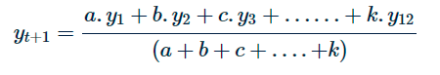

such that a<b<c<.....k, where k is the largest weight assigned to the most recent data point i.e. y12.

**5. exponential smoothing technique**

Exponential smoothing technique. In this smoothing technique, the forecast observation data, Yt+1, is a function of the level component that is denoted by lt. Here, the level component is written as follows:  


 The most recent value yt takes a weight of α, also known as the level smoothing parameter, whereas the previous observation’s level component takes the value of 1−α.

The values of α lie between 0 and 1. You can try to change the values of α such that for an optimum value of this level smoothing parameter the forecast fits well with the actual values and the subsequent values of the error terms are extremely low.

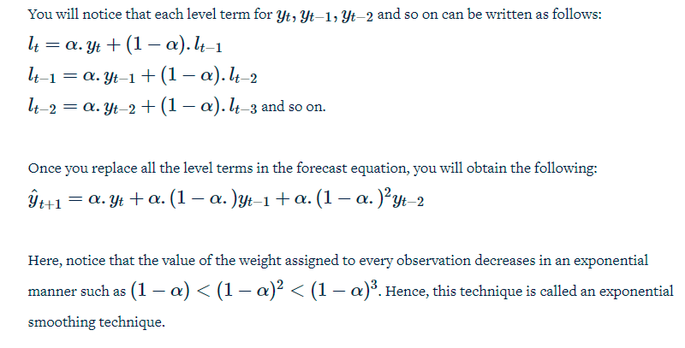

**6. Holt exponential smoothing technique**

Holt's exponential smoothing technique which captures both level and trend of a time series in the forecast.  the forecast equation is a function of both level and trend that is

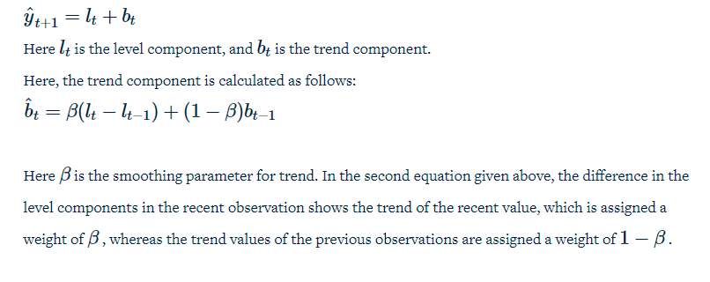

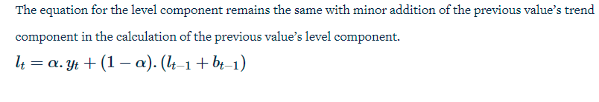

**7. Holt-Winters's Exponential Smoothing**

'Holt-Winters' Exponential Smoothing technique which forecasts based on level, trend, and seasonality of a time series.



Here, m is the number of times a season repeats during a period. The seasonal component is calculated using the following equation:

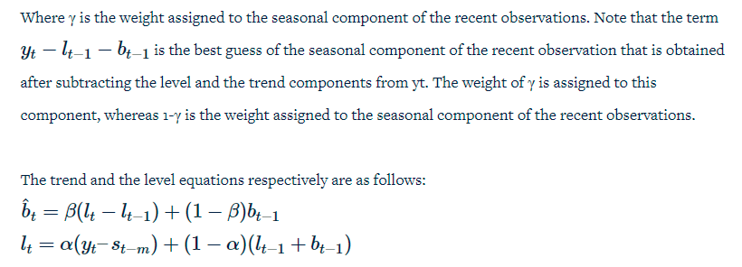

smoothing techniques: additive and multiplicative methods. In a time-series data, if the seasonality is not a function of the level component or the difference between subsequent troughs of the time series data does not increase as you progress in the graph, then the Holt-Winters’ additive method works best. You q used this method for the quarterly ice cream sales example because as you can observe in the image below, the difference between the troughs does not increase.

But suppose seasonality is a function of the level and the difference between the troughs of the time series data increases as you progress in the graph, then you use the multiplicative method.

# **Popular error measures**

Popular error measures are:-

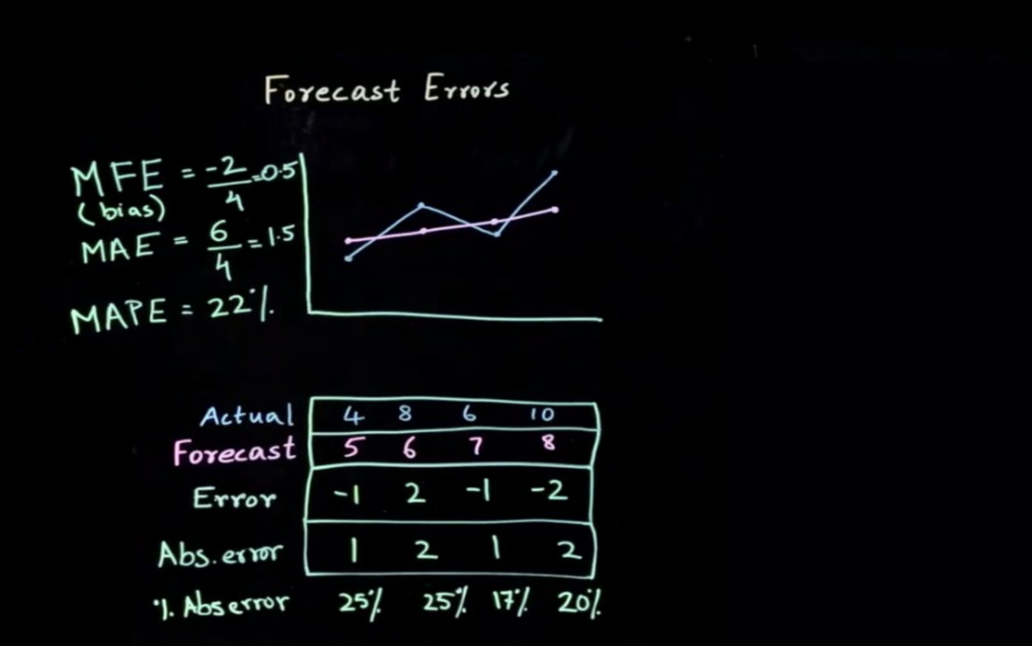

**Mean Forecast Error (MFE):** In this naive method, you simply subtract the actual values of the dependent variable, i.e., 'y' with the forecasted values of 'y'. This can be represented using the equation below.



**Mean Absolute Error (MAE):** Since MFE might cancel out a lot of overestimated and underestimated forecasts, hence measuring the mean absolute error or MAE makes more sense as in this method, you take the absolute values of the difference between the actual and forecasted values.



**Mean Absolute Percentage Error (MAPE):** The problem with MAE is that even if you get an error value, you have nothing to compare it against. For example, if the MAE that you get is 1.5, you cannot tell just on the basis of this number whether you have made a good forecast or not. If the actual values are in single digits, this error of 1.5 is obviously high but if the actual values are, say in the order of thousands, an error of 1.5 indicates a good forecast. So in order to capture how the forecast is doing based upon the actual values, you evaluate mean absolute error where you take the mean absolute error (MAE) as the percentage of the actual values of 'y'.

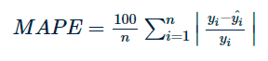

**Mean Squared Error (MSE):** The idea behind mean squared error is the same as mean absolute error, i.e., you want to capture the absolute deviations so that the negative and positive deviations do not cancel each other out. In order to achieve this, you simply square the error values, sum them up and take their average. This is known as mean squared error or MSE which can be represented using the equation below.

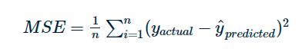

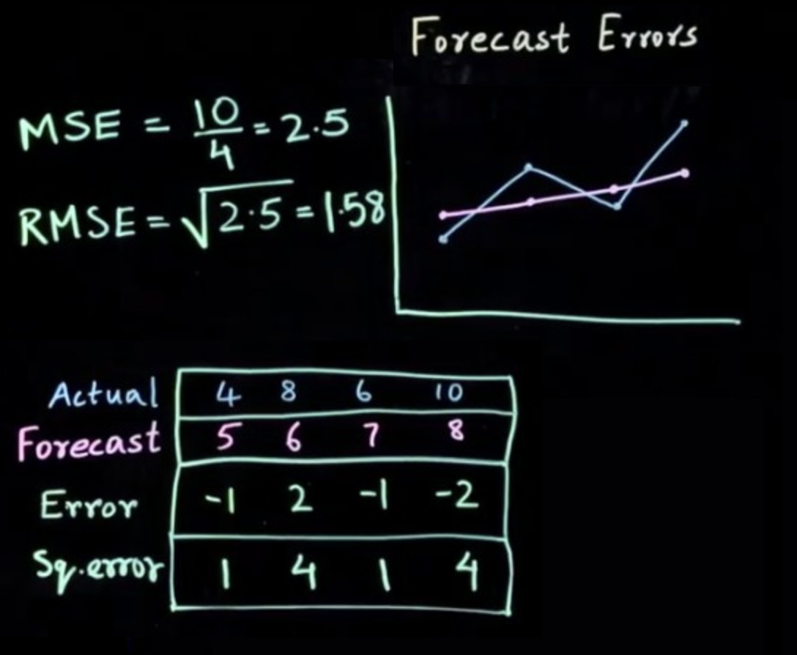

**Root Mean Squared Error (RMSE):**Since the error term you get from MSE is not in the same dimension as the target variable 'y' (it is squared), you deploy a metric known as RMSE wherein you take the square root of the MSE value obtained.

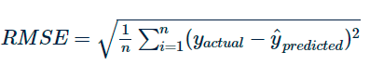

# **Cross-validation**

Basically cross-validation in time series is not done in the same way you might have done for any of the classical machine learning algorithms. This caveat stems from the fact that order matters in time series. So while building a forecast model, the test dataset is always on the right-hand side of the train dataset. **Let's understand the two types of validation**:-

### **One-Step Validation**

The testing set is just one step ahead to the training set. So suppose out of 15 data points, you decided to keep the first 10 of them as 'train' and the next 5 of them as 'test'. Now, the data points in the test set will be taken one-by-one starting from the left since you need all the previous values to predict the future values. So firstly, you take the 11th point to be the test set.

Once this value is successfully forecasted, you move on to the 12th point which is now your new test point and so on until you forecast for all the 5 points. This idea is represented in the image below. Here the blue squares represent the train data, the **yellow squares represent the test data**, and the **purple ones are the future values** for which the initial test points need to be predicted first. In the image below, you have 7 test data points, hence it takes 7 iterations (or forecasts) to fully predict the test set.

### **Multi-Step Validation**

This is the same as one-step validation, the only difference being that you do not consider a few points to the immediate right of the last training datapoint but rather skip a few of these points to make forecasts well into the future. This can be seen in the image below.

